Student Name: ARYAN DAHIYA UID: 24BAI70697
Branch: AIT-CSE-AIML Section/Group: 24AIT_KRG1_B
Semester: 5
Subject Name: ADBMS Subject Code: 24CSP-310

Question A:
A university administration requires an analytical performance report for each academic unit. Write a PostgreSQL solution to calculate the average marks scored by students grouped by their respective departments. The solution must join the student profile, course subjects, and grade marks tables, returning a breakdown sorted by the highest average marks down to the lowest.
Solution:

- Query:
SELECT D.DEPT_NAME AS DEPARTMENT,
ROUND(AVG(M.MARKS_SCORED), 2) AS AVERAGE_MARKS
FROM DEPARTMENTS AS D
JOIN
STUDENTS AS S
ON D.DEPT_ID=S.DEPT_ID
JOIN
MARKS AS M
ON
S.STUDENT_ID = M.STUDENT_ID
GROUP BY D.DEPT_NAME
ORDER BY AVERAGE_MARKS DESC;

- Output
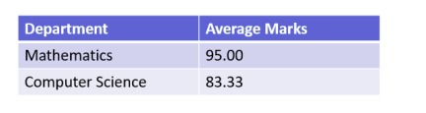

Question B:
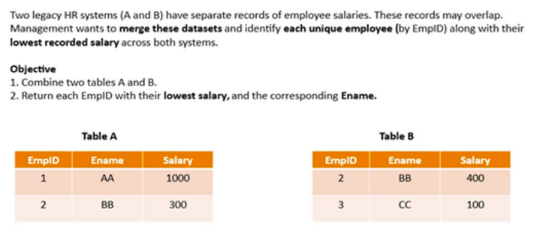
Query:
SELECT EMPID, MIN(ENAME) AS ENAME, MIN(SALARY) AS SALARY
FROM
(
SELECT * FROM A
UNION ALL
SELECT * FROM B
) AS INTERMEDIATE_RES
GROUP BY EMPID;

Output:
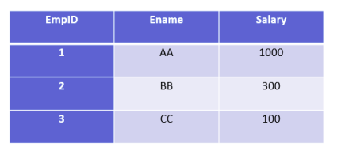

Question C:
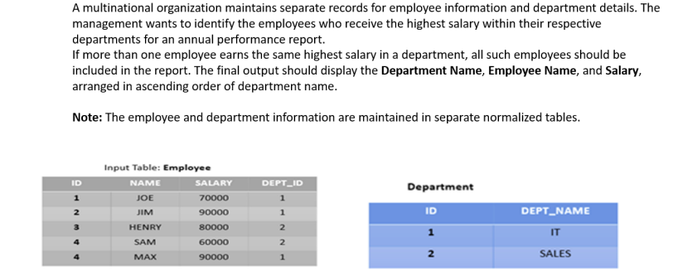

Query :
a)
SELECT D.DEPT_NAME, E.NAME, E.SALARY
FROM
EMPLOYEE AS E
JOIN
DEPARTMENT AS D
ON E.DEPARTMENT_ID = D.ID
WHERE E.SALARY IN
(
SELECT MAX(SALARY)
FROM EMPLOYEE AS E1
WHERE E1.DEPARTMENT_ID = E.DEPARTMENT_ID
)
ORDER BY DEPT_NAME;

b)
SELECT D.DEPT_NAME, E.NAME, E.SALARY
FROM
EMPLOYEE AS E
JOIN
DEPARTMENT AS D
ON E.DEPARTMENT_ID = D.ID
WHERE E.SALARY IN
(
SELECT MAX(SALARY)
FROM EMPLOYEE AS E1
WHERE E1.DEPARTMENT_ID = E.DEPARTMENT_ID
AND E1.SALARY NOT IN
(
SELECT MAX(SALARY)
FROM EMPLOYEE AS E2
WHERE E2.DEPARTMENT_ID = E1.DEPARTMENT_ID
)
)
ORDER BY DEPT_NAME

Output:
